**Setting up Application Environment**

**Install IBM Cloud CLI**

|  |  |
| --- | --- |
| Date | 07-11-2022 |
| Team ID | PNT2022TMID17200 |
| Project Name | CustomerCare Registry |

**Step 1.** Navigate to cloud.ibm.com

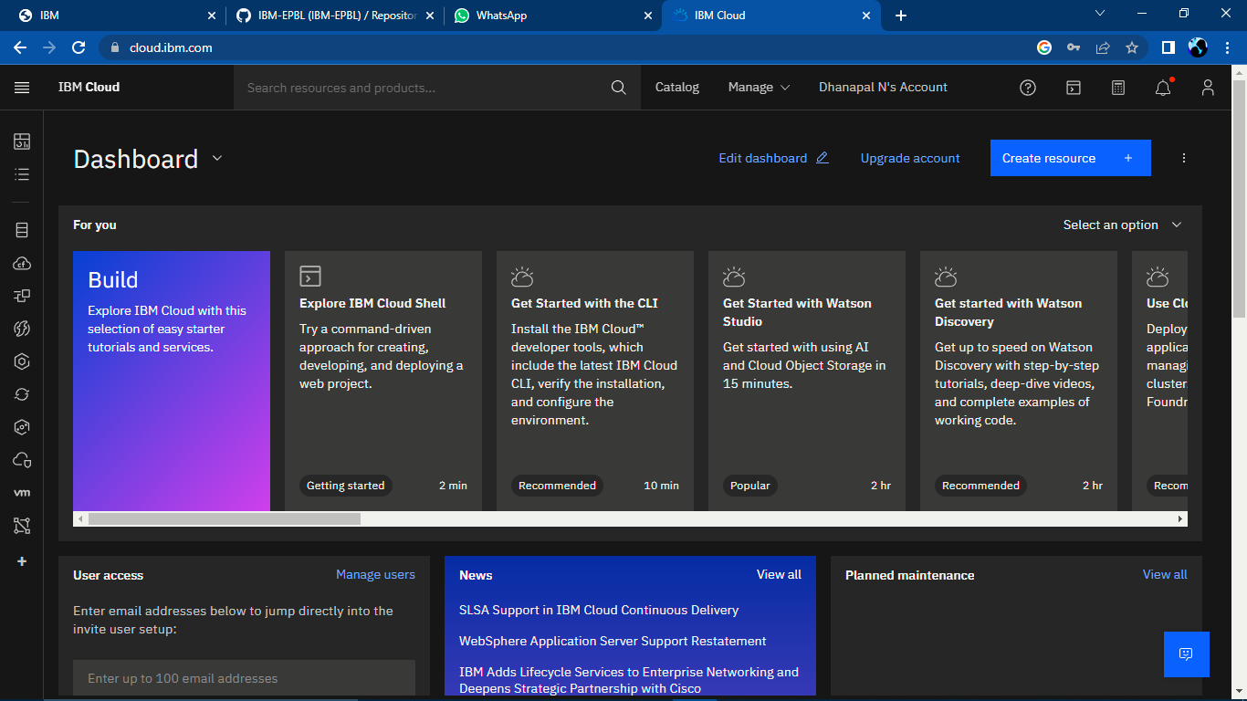

**Step 2**. Search on Container Registry and give get started and follow the steps to install IBM Cloud CLI

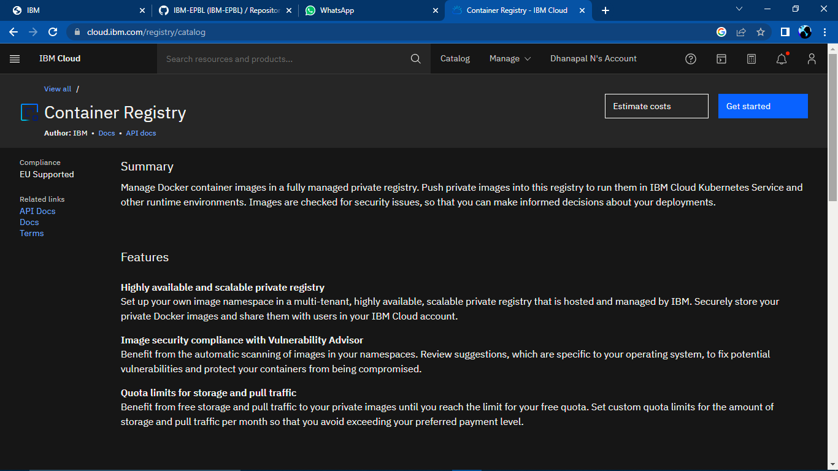

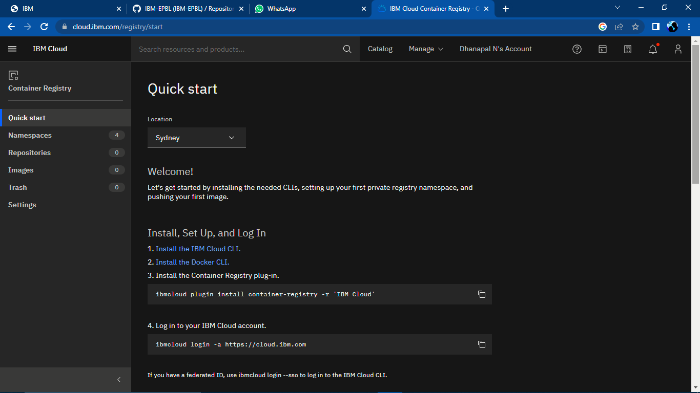

**Step 3**.Download windows 64 bit installer

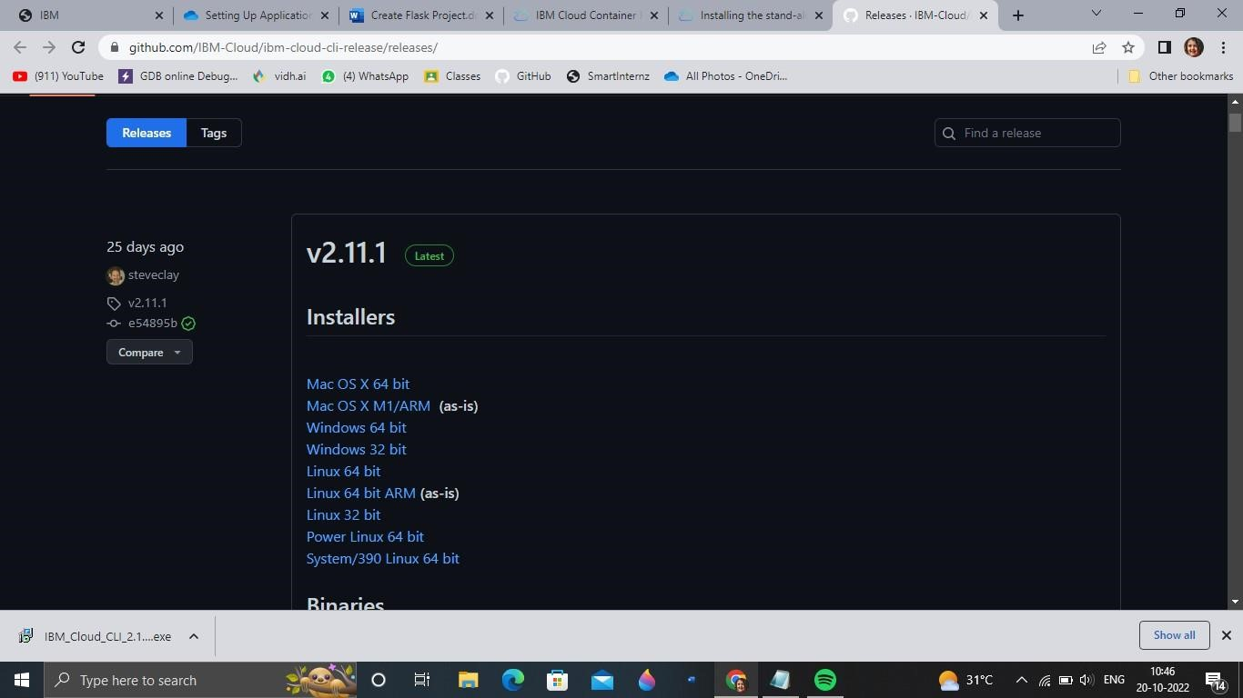

**Step 4.** Open the downloaded .exe file and run it to install IBM Cloud CLI

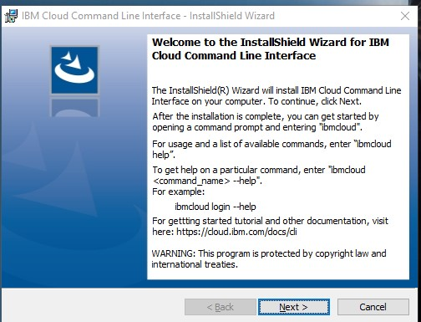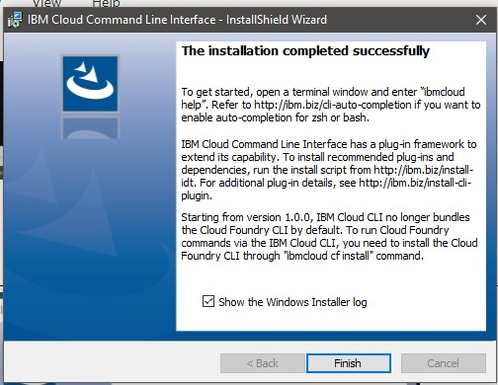

**OUTPUT:**

IBM Cloud CLI is installed successfully